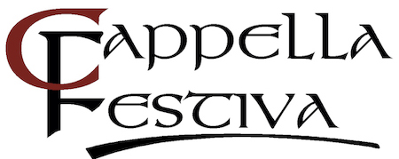

SUMMER 2020
We hope this Cappella membership newsletter finds you all well. While we wait until we can be together in person again, please join us as we look back on the year and look forward to what is to come.
We miss you!

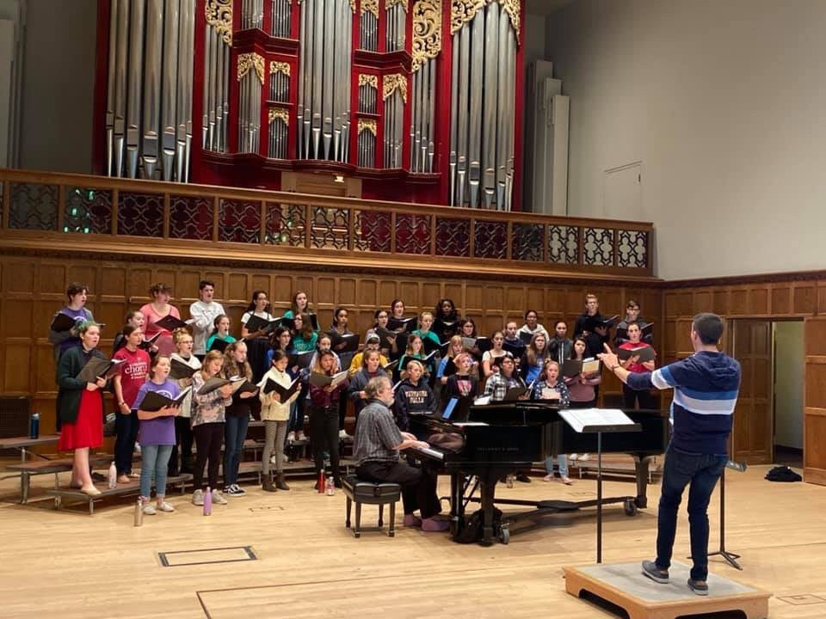

We are rehearsing here (photo above) in preparation for a collaborative concert performance that took place on Sunday, October 27, 2019. Collaborating choirs:
Cappella Festiva Treble Choir, conductor Matthew Zydel
Cor Capriccio Children’s Choir, conductor Elizabeth Clifton
Children’s Chorus of Maryland, conductor Susan Bialek
They performed pieces by Bob Chilcott, Andrea Ramsey and Jim Papoulis in the beautiful Skinner Hall of Music at Vassar College.

https://www.youtube.com/watch?v=zjl2IqSI9e4

Enjoy (link above) watching Cappella Chamber Choir rehearsing on a beautiful Saturday morning back in October while preparing for an upcoming concert: Dreams of a Glorious Day. Take a listen to their gorgeous voices sing Let the River Run, lyrics and music by Carly Simon.

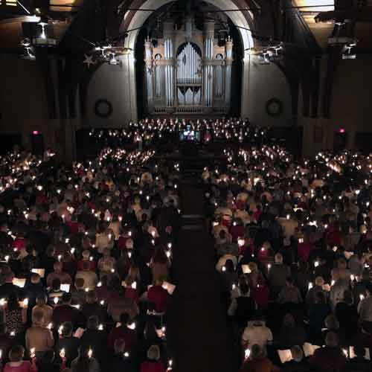
Our glorious annual Lessons and Carols in the Vassar College Chapel. All three of our choirs performed.

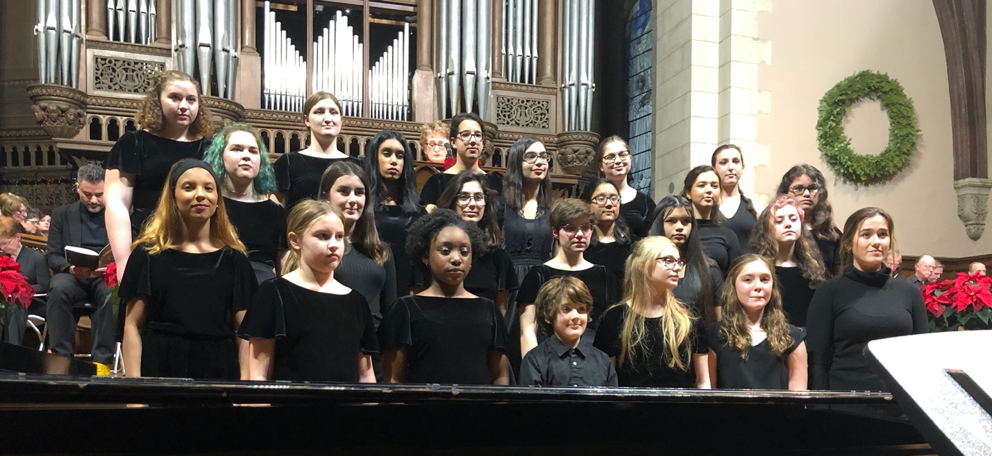

Our Treble Choir performed at Lessons & Carols on Sunday evening, December 8, 2019 to a packed and full chapel.

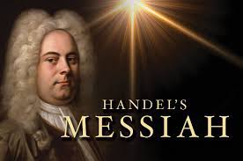

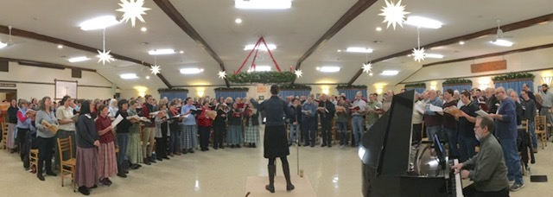

Back in December ~ Annual joint rehearsal of Cappella Festiva and the Bruderhof Community, Maple Ridge, for Handel's Messiah. About 200 voices were expertly conducted by Dr. Christine Howlett. Always an enjoyable, uplifting experience, and the Bruderhof's cookies are outstanding!

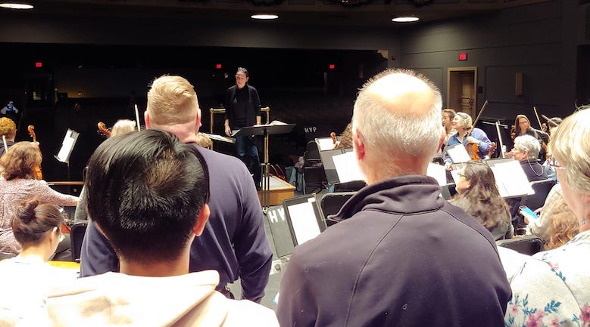

"First rehearsal for Saturday's sold out performance of Handel's Messiah with the Hudson Valley Philharmonic. They, uh, don't make mistakes."
~ Wayne Delia

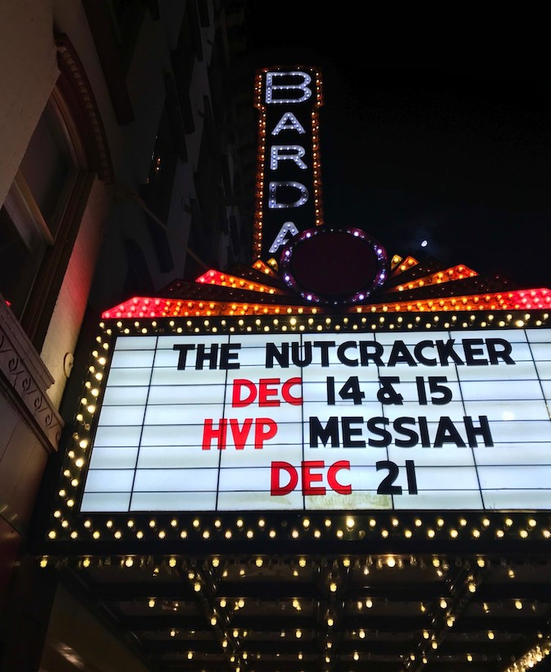

The Bardavon Marquee
Our community has come to love and rely on this perennial favorite,
Handel's Messiah
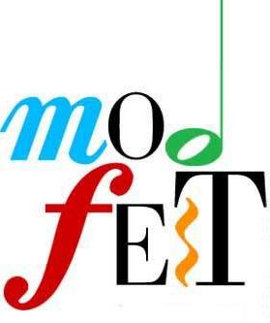
Our last live performance
(photo below)
Cappella Festiva Treble Choir performed at Modfest
Saturday, February 8th at 3:00pm
Skinner Hall of Music
Vassar College
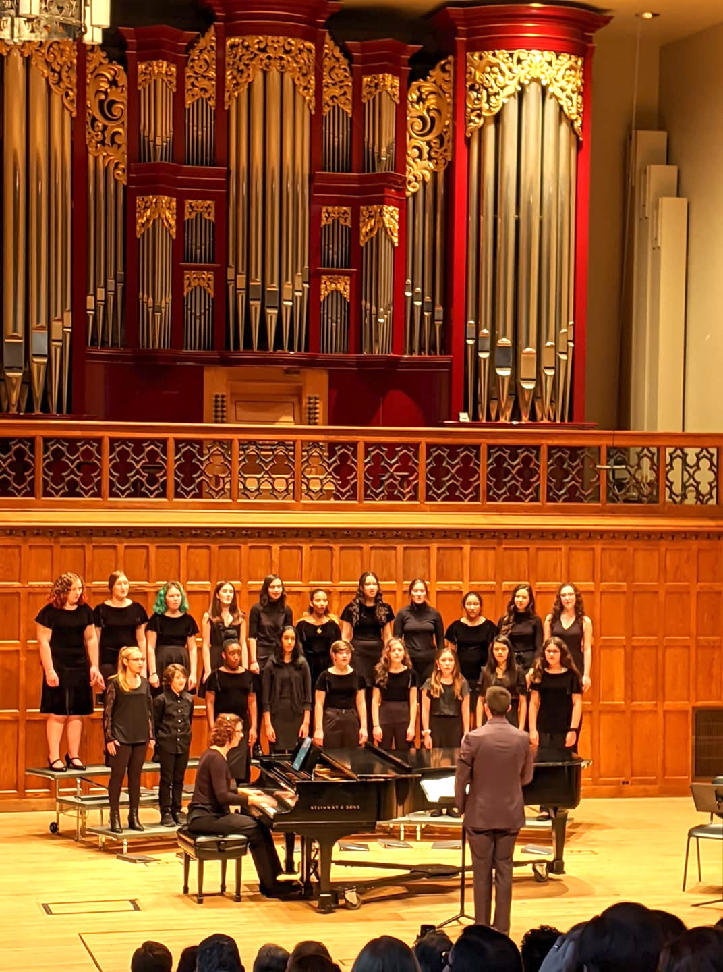

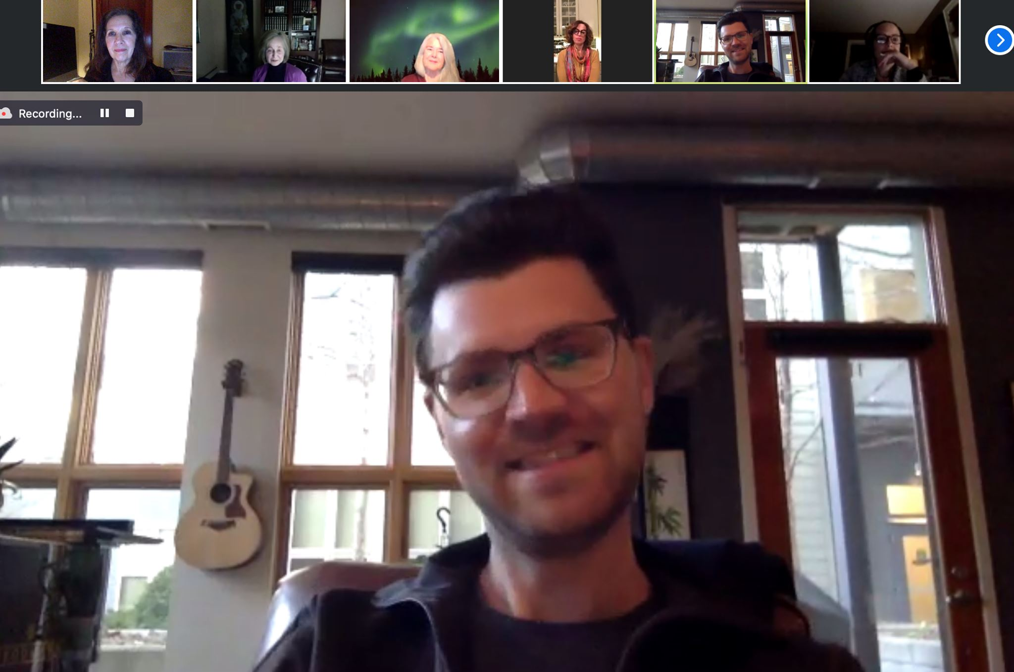

Jake Runestad, American composer, was our guest at Cappella's zoom gathering in April. This was especially meaningful since we sang one of his pieces "Come to the Woods" at our fall concert. 60+ singers had the opportunity to ask him questions. Referring to "Come to the Woods," he answered, "How do I embody the soundscape of that world? I definitely have a picture in my head. I picture John Muir skipping down a trail...." Jake gave us a glimpse of how and why he writes. It was an honor to host Jake Runestad and we hope to sing more of his music in the future.

https://www.youtube.com/watch?v=fAt5OWpSzm4&t=12s

After online rehearsals this spring, our CFTC season ended in June with a "Senior Send Off' celebration as we honored our 5 high school seniors who graduated. Click link above to view our send off.

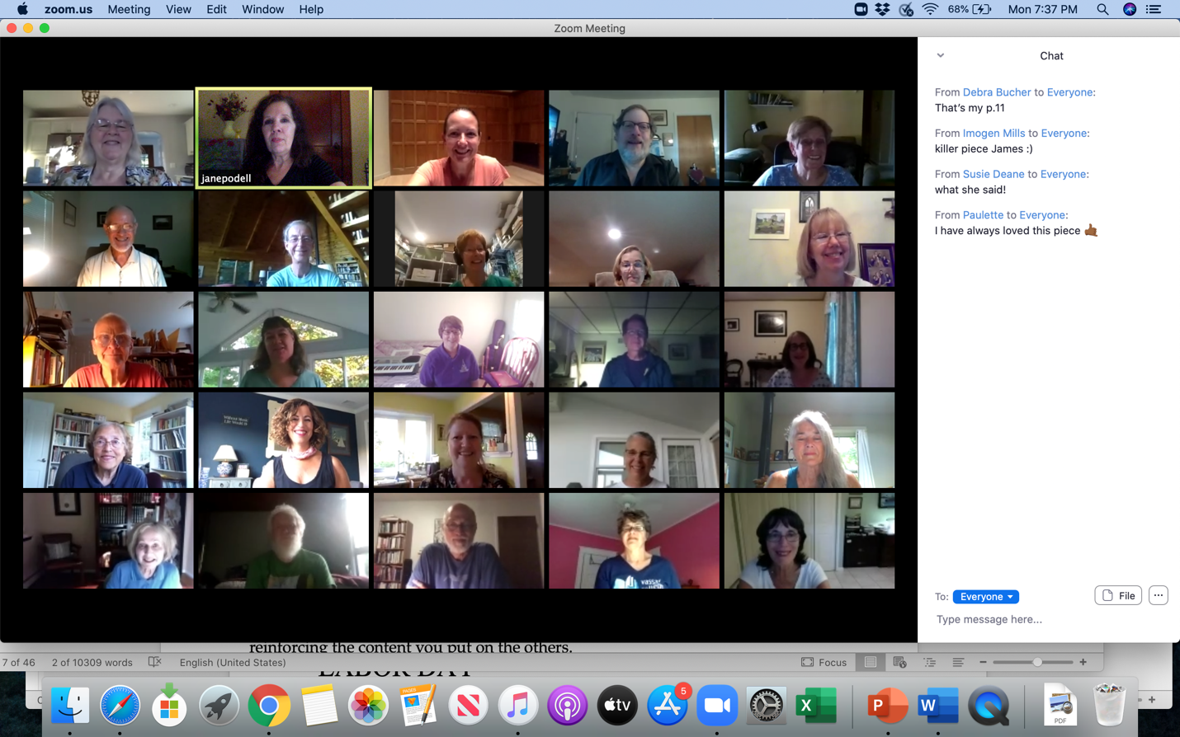

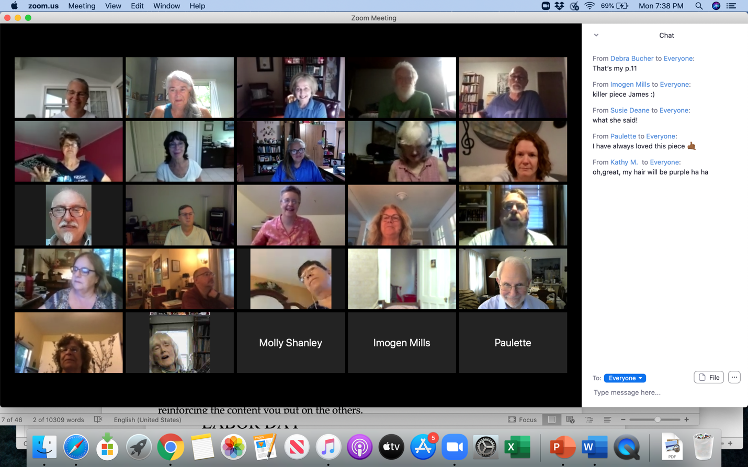
Our last virtual rehearsal in July of 2020.

